Brian Jones

4/25/2013

CIS 113

Week 11 Homework (47 a-d, 48, Sorting-Algorithm Benchmarks)

1. 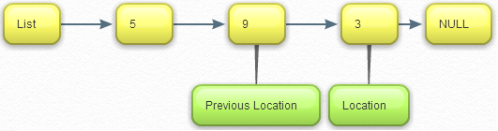
   1. 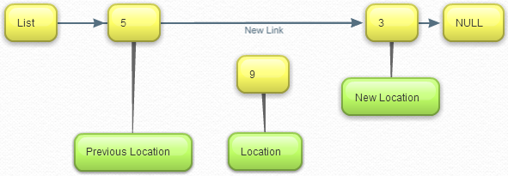

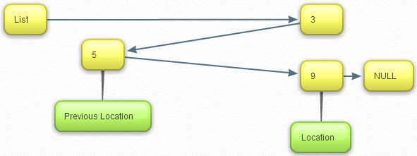

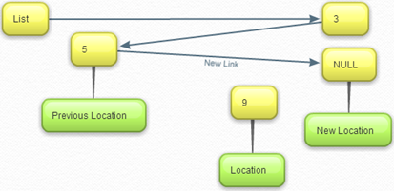

**Console Output**

Unsorted List:

apple

orange

pear

Sorted List:

apple

orange

pear

1. G

Sorting-Algorithm Benchmarks:

|  |  |  |  |  |
| --- | --- | --- | --- | --- |
|  | **Sorting Algorithm (SIZE = 10)** | | | |
|  | **Selection** | **Bubble** | **Short Bubble** | **Insertion** |
| **Comparisons** | 63.00 | 63.00 | 63.00 | 18.00 |
| **Swaps** | 9.00 | 45.00 | 45.00 | 90.00 |
| **Efficiency** | 6.00 | 6.00 | 6.00 | 1.00 |
| **Improved Efficiency** | 7.00 | 10.00 | 10.00 | 10.00 |
| **CPU Time** | 0.00s | 0.00s | 0.00s | 0.00s |
|  | **Sorting Algorithm (SIZE = 10)** | | | |
|  | **Selection** | **Bubble** | **Short Bubble** | **Insertion** |
| **Comparisons** | 5,148.00 | 5,148.00 | 5,148.00 | 198.00 |
| **Swaps** | 99.00 | 4,950.00 | 4,950.00 | 9,900.00 |
| **Efficiency** | 51.00 | 51.00 | 51.00 | 1.00 |
| **Improved Efficiency** | 52.00 | 100.00 | 100.00 | 100.00 |
| **CPU Time** | 0.00s | 0.00s | 0.00s | 0.00s |
|  | **Sorting Algorithm (SIZE = 10)** | | | |
|  | **Selection** | **Bubble** | **Short Bubble** | **Insertion** |
| **Comparisons** | 501,498.00 | 501,498.00 | 501,498.00 | 1,998.00 |
| **Swaps** | 999.00 | 499,500.00 | 499,500.00 | 999,000.00 |
| **Efficiency** | 501.00 | 501.00 | 501.00 | 1.00 |
| **Improved Efficiency** | 502.00 | 1,000.00 | 1,000.00 | 1,000.00 |
| **CPU Time** | 0.01s | 0.01s | 0.01s | 0.01s |
|  | **Sorting Algorithm (SIZE = 10)** | | | |
|  | **Selection** | **Bubble** | **Short Bubble** | **Insertion** |
| **Comparisons** | 50,014,998.00 | 50,014,998.00 | 50,014,998.00 | 19,998.00 |
| **Swaps** | 9,999.00 | 49,995,000.00 | 49,995,000.00 | 99,990,000.00 |
| **Efficiency** | 5,001.00 | 5,001.00 | 5,001.00 | 1.00 |
| **Improved Efficiency** | 5,002.00 | 10,000.00 | 10,000.00 | 10,000.00 |
| **CPU Time** | 0.12s | 0.10s | 0.10s | 0.10s |